neuralBlack

**Brain Tumor Detection Using Deep Learning**

**Submitted by**

NAME OF THE CANDIDATES

ADITYA ASHOK PISE (21BCE11662) ADELIN PARINITA (21BCE10705)

*in partial fulfillment for the award of the degree of*

BACHELOR OF TECHNOLOGY

**in**

COMPUTER SCIENCE AND ENGINEERING



**SCHOOL OF COMPUTING SCIENCE AND ENGINEERING**

## VIT BHOPAL UNIVERSITY

**KOTHRIKALAN, SEHORE MADHYA PRADESH - 466114**

OCTOBER-NOVEMBER, 2023

## LIST OF FIGURES

|  |  |  |
| --- | --- | --- |
| **FIGURE NO.** | **TITLE** | **PAGE NO.** |
| 1 | Illustration of the major functional blocks of four  CNN models | 9 |
| 2 | Brain tumor dataset:   1. no tumor and 2. brain tumor | 10 |
| 3 | Overview of the proposed model | 10 |
| 4 | Flipping data augmentation:   1. original 2. horizontal flipping 3. vertical flipping | 11 |
| 5 | Clockwise rotation data augmentation:   1. original 2. 90-degree anticlockwise 3. 180-degree anticlockwise 4. 270-degree anticlockwise. | 11 |
| 6 | Brightness data augmentation:   1. original image 2. with brightness factor 0.2 3. with brightness factor 0.4. | 12 |
| 7 | Confusion matrix of VGG-19 model with 16 batch  size | 14 |
| 8 | Training and Validation Loss | 14 |
| 9 | Training and Validation Accuracy | 14 |
| 10 | ROC CURVE | 15 |

**LIST OF TABLES**

|  |  |  |
| --- | --- | --- |
| **TABLE NO.** | **TITLE** | **PAGE NO.** |
| 1 | Comparison of existing state-of-art models | 8 |
| 2 | 1. Different architectures of CNN: VGG 16 and VGG 19 2. Different architectures of CNN and parameters of all the models | 9 |

**ABSTRACT**

A brain tumor (BT) is an unexpected growth or fleshy mass of abnormal cells. Depending upon their cell structure they could either be benign (noncancerous) or malign (cancerous). This causes the pressure inside the cranium to increase that may lead to brain injury or death. This causes excessive exhaustion, hinders cognitive abilities, headaches become more frequent and severe, and develops seizures, nausea, and vomiting. Therefore, in order to diagnose BT computerized tomography (CT), magnetic resonance imaging (MRI), positron emission tomography (PET), and blood and urine tests are implemented. However, these techniques are time consuming and sometimes yield inaccurate results. Therefore, to avoid such lengthy and time-consuming techniques, deep learning models are implemented that are less time consuming, require less sophisticated equipment, yield results with greater accuracy, and are easy to implement. This paper proposes a transfer learning-based model with the help of pretrained VGG19 model. This model has been modified by utilizing a modified convolutional neural network (CNN) architecture with preprocessing techniques of normalization and data augmentation. The proposed model achieved the accuracy of 89%. It is concluded from the results that proposed model performs better as compared to other state-of-art models. For training purpose, the dataset has been taken from the Kaggle having 300 images with 150 with brain tumor (BT) images and 150 no tumor (NT) images. With such results, these models could be utilized for developing clinically useful solutions that are able to detect BT in CT images.

**TABLE OF CONTENTS**

|  |  |  |
| --- | --- | --- |
| CHAPTE R NO. | TITLE | PAGE NO. |
|  | List of Abbreviations | 3 |
| List of Figures | 2 |
| List of Tables | 3 |
| Abstract | 4 |
| 1 | INTRODUCTION | 6 |
|  | RELATED WORK | 7 |
| 2 | 2.1)BRAIN TUMOR PREDICTION USING | 8 |
|  | PRETRAINED CNN MODELS |  |
|  | RESEARCH METHODOLOGY | 9 |
|  | 3.1) DATASET | 9 |
| 3 | 3.2) PROPOSED METHODOLOGY | 9 |
|  | 3.2.1) NORMALIZATION | 10 |
|  | 3.2.2) AUGMENTATION | 10 |
|  | EXPERIMENTS AND RESULTS | 12 |
| 4 | * 1. PERFORMANCE METRICS   2. THE TRAINING PERFORMANCE COMPARISON | 12  12 |
|  | 4.3) CONFUSION MATRIX | 12 |
| 5 | CONCLUSION | 15 |
|  | REFERENCES | 16 |

# INTRODUCTION:

The nervous system of the human body is controlled by the important organ called as the brain. It consists of 100 billions of nerve cells [1]. If any nerve cells are damaged, it may cause several human health problems which leads to abnormality in the brain of the human body. These damaged cells give an adverse effect on tissues of the brain. Such problem increases the risk of brain tumors in the human body [2]. Primary and metastatic are the two different categories of brain tumors. Primary brain tumors originated inside the brain which includes nerves, blood vessels, or various glands of the brain whereas metastatic brain tumor is developed in the different body parts of the human body like breasts or lungs and migrated into the brain [3]. Tumors are malignant or benign. Malignant brain tumors grow very fast in the body and are also cancerous. The most common malignant brain tumor is glioblastoma [4]. In benign brain tumors, the cells grow at a relatively slow speed are noncancerous too. Such type of tumor does not spread into other parts of the body. If it is removed safely from surgery, it will not come back into the body [5]. If the brain tumors are diagnosed at early stages, it increases the survival rate of the patients. Other primary brain tumors include pituitary tumors which are usually benign and are located near the pituitary glands; pineal gland tumors which could be either malignant or benign; lymphomas located at central nervous system which is malignant; and meningiomas and schwannomas, both of them occur in people in the age group in between 40 and 70 and mostly are benign.

According to World Health Organization (WHO), there exist four grades of brain tumors [6]. Grading is the process of segmenting the brain tumor cells on the basis of their identification. The more the abnormal the cells represent, the higher the grade is detected. Grades I and II depict the lower level tumors whereas grade III and IV tumors comprise the most extreme ones [7]. In grade 1, the cells appear to be normal, hence less likely to infect other cells. In grade 2, cells appear to be slowly growing into the adjacent neighboring brain tissue. In grade 3, cells appear to be more abnormal and start spreading to other parts of the brain and central nervous system. In grade 4, cells exhibit more abnormality and start growing into tumors and spread these to other parts of the brain and spinal cord. A benign tumor is of low grade whereas malignant tumor is of high grade [8]. Depending upon the location, type, and size of the tumor, different methods are employed to treat different tumors. Surgery is the most widely recognized treatment of tumor and has no adverse effects [9]. Grade 4 tumors can also lead to neurodegenerative disease such as Alzheimer’s disease, Parkinson’s disease, and Huntington’s disease which lead to inability of basic cognitive and motor functions of the body and may lead to dementia.

To detect the progress in modelling process, computed tomography images of the brain are used. Computed tomography (CT) is not only an alternate method for the detection of tumor but also provides more data about the given medical image [10].

This paper encloses a novel CNN-based model that classifies BT in two categories, i.e., BT and NT. Moreover, the CNN model is trained and developed for a large dataset. The accuracy of the proposed model has been enhanced by implementing preprocessing techniques like normalization and data augmentation on the dataset. Thus, automated systems like these are helpful in saving time and also improve the efficiency in clinical institutions.

# RELATED WORK:

Most of the researchers working on the binary classification of BT are comparatively using a similar dataset to design a CNN-based model that may not be versatile. The authors working on a large dataset have also implemented binary classification only with lesser accuracy. Table 1 depicts comparison of existing state-of-art models in which approach used and challenges of the approach are given in details.

|  |  |  |  |  |
| --- | --- | --- | --- | --- |
| Citation/year of publishing | Reference | Approach | Objective | Challenges of the approach |
| 2021 | FIN | CDLLC-CNN, VGG19, VGG16 | To develop brain tumor classification technique by using CDLLC on CNN. | Dataset contained 3064 brain tumor images. It implemented binary classification and yielded an accuracy of 96.39%. |
| 2021 | JAIHC | SVM-CNN, VGG16, VGG19 | To distinguish brain tumor from healthy individuals using SVM with CNN. | Dataset contained 1426 brain tumor images. It implemented binary classification and yielded an accuracy of 95.82%. |
| 2021 | MMTA | RNGAP-CNN,  DenseNet201, VGG16 | To predict brain tumor from normal individual by RNGAP model on CNN. | Dataset contained 3064 brain tumor images. It implemented binary classification and yielded an accuracy of 97.08%. |
| 2021 | MRT | 3DCNN,  DenseNet201, VGG 16 | To detect brain tumor on CT scans using 3DCNN technique. | Dataset contained 1074 brain tumor images. It implemented binary classification and yielded an accuracy of 92.67%. |
| 2021 | NCA | MSMCNN,  DenseNet121, VGG19 | To automatically classify CT images into brain tumor and normal individuals by using MSMCNN. | Dataset contained 374 brain tumor images. It implemented binary classification and yielded an accuracy of 96.36%. |
| 2019 | BS | HSANN, VGG19,  DenseNet201 | To classify BT by using HSANN architecture. | Dataset contained 3064 brain tumor images. It implemented binary classification and yielded an accuracy of 97.33%. |
| 2017 | SIVP | ELM-CNN,  DenseNet201, VGG16 | To develop an ELM system to early diagnose BT individuals. | Dataset contained 1074 brain tumor images. It implemented binary classification and yielded an accuracy of 97.8%. |
| 2020 | JDI | 3DCNN,  DenseNet201 | To classify BT analysis by using 3DCNN | Dataset contained 1074 brain tumor images. It implemented binary classification and yielded an accuracy of 96.49%. |
| 2021 | JCS | Deep-CNN, DenseNet121, DenseNet201 | To develop Deep-CNN system that can determine BT by using CT scans. | Dataset contained 121 brain tumor images. It implemented binary classification and yielded an accuracy of 94.58%. |
| 2021 | WMPBE | CNN, VGG16, VGG19,  DenseNet201 | To diagnose BT by using an ensemble system of CNN. | Dataset contained 3064 brain tumor images. It implemented binary classification and yielded an accuracy of 84.19%. |

**Table 1: Comparison of existing state-of-art models.**

From Table 1, it can be observed that a small size of dataset has been used to train and validate the existing state-of-art models. However, Gu et al. [1], Kumar et al. [3], Abd El Kader et al. [6], and Abiwinanda et al. [10] utilized comparatively larger datasets to validate their models. But, it can be noticed that these studies have worked on mostly binary classification.

The proposed model in this research paper is trained on a large size of dataset having 1800 images. The proposed model classifies the brain tumor into two categories that is with brain tumor (BT) and no tumor (NT).

* 1. **Brain Tumor Prediction Using Pretrained CNN Models:**

For a wide range of healthcare research and applications, the convolutional neural network models had always demonstrated to acquire higher-grade results. Still, building these pretrained convolutional neural network models from scratch had always been strenuous for prediction of this neurological disease due to restricted access of computed tomography (CT) images [11]. These pretrained models are derived from the concept of transfer learning, in which a trained D.L model from a large dataset is used to elucidate the problem with a smaller dataset [12]. Due to this, not only the requirement for a large dataset is removed but also removes excessive learning time required by various D.L models. This paper encloses four D.L models such as DenseNet121, DenseNet201, VGG16, and VGG19. These models were trained on ImageNet and then fine-tuned over BT images. In the last layer of these pretrained models, the fully connected layer (FCL) is inserted [13]. The architectural description and functional blocks of all architectures are shown in Tables 2(a), parameters are shown in Table 2(b), and Figure 1 displays the diagrammatic representation for these models, respectively.

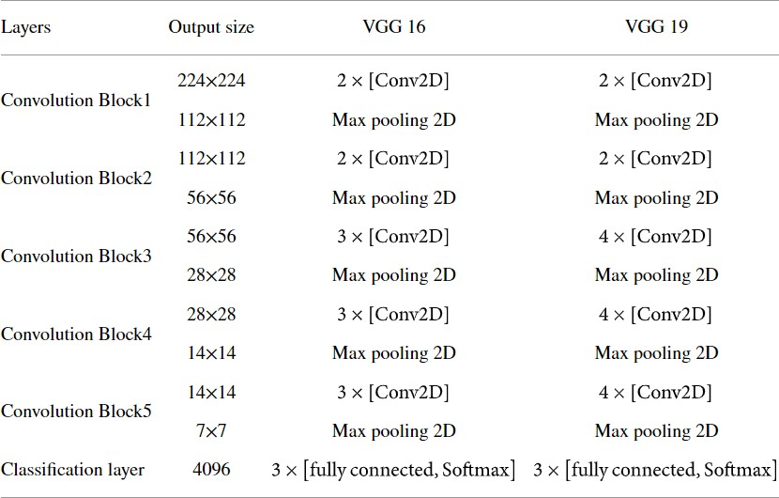

**2(a): Different architectures of CNN: VGG 16 and VGG 19**

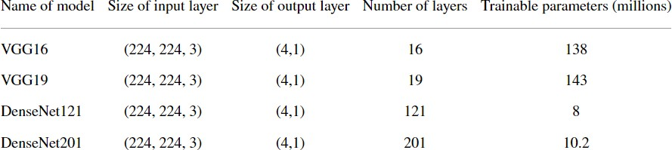

**2(b): Different architectures of CNN and parameters of all the models**

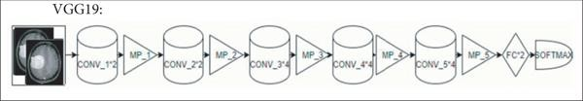

**Figure 1: Illustration of the major functional blocks of four CNN models.**

VGG19 comprises sixteen CL, five MPL, two FCL, and one SML with 143 million trainable parameters [17].

# RESEARCH METHODOLOGY:

Many studies and research have been conducted on BT but very less work has been implemented and published on comparative analysis of BT using four D.L models which are VGG16, VGG19, DenseNet121, and DenseNet201. Then, these models results are displayed and compared by plotting graphs of accuracy, loss, and learning curves and determining validation rules [14].

## DATASET:

For the proposed solution, an open access dataset is used which is available on (<https://www.kaggle.com/datasets/ahmedhamada0/brain-tumor-detection>) by Ahmed Hamada and is named as ‘Br35H :: Brain Tumor Detection’. The dataset consists of two categories of with brain tumor (BT) and no brain tumor (NT) images which had a total of 1500 and 1500 images, respectively [15]. All of them are of size 467 x 586 x 3.

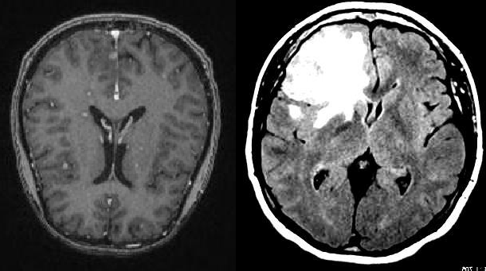

**Figure 2: Brain tumor dataset: (a) no tumor and (b) brain tumor.**

## PROPOSED METHODOLOGY:

The proposed BT detection model is depicted in Figure 3. This model classifies BT image into four categories, namely, NT and BT.

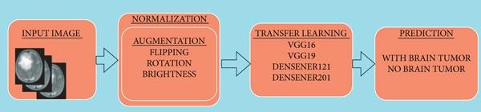

**Figure 3: Overview of the proposed model.**

## NORMALIZATION

The dataset underwent normalization pre-processing technique so as to keep its numerical stability to D.L models. Initially, these CT images are in monochromatic or in grayscale format having pixel values in between 0 and 255. By normalizing the input images, D.L models can be trained faster [16].

## AUGMENTATION

In order to improve effectiveness of a D.L model, a large amount of dataset is required. However, accessing these datasets often come along with numerous restrictions [17]. Therefore, in order to surpass these issues, data augmentation techniques are implemented to increase the number of sample images in the sample dataset [18]. Various data augmentation methods such as flipping, rotation, brightness, and zooming are implemented. Both horizontal flipping and vertical flipping techniques are shown in Figure 4.

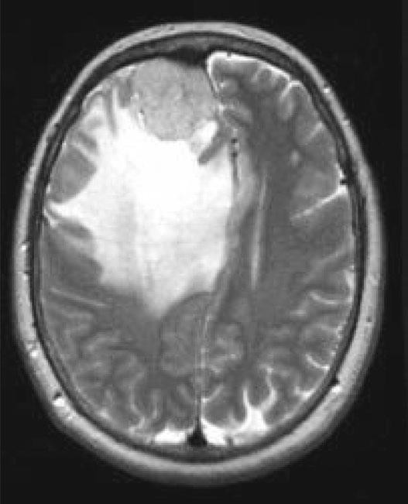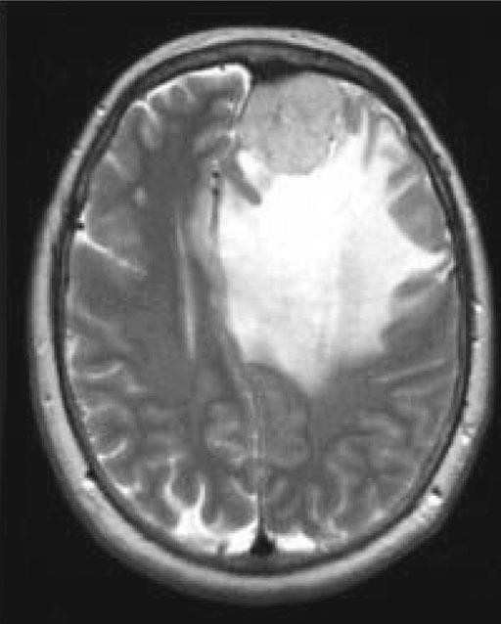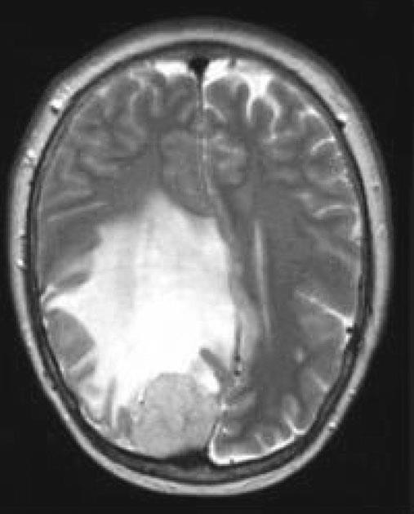

**Figure 4: Flipping data augmentation: (a) original, (b) horizontal flipping, and (c) vertical flipping.**

Rotation augmentation technique as shown in Figure 5 is implemented in clockwise direction by an angle of 90 degree each.

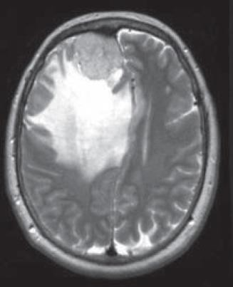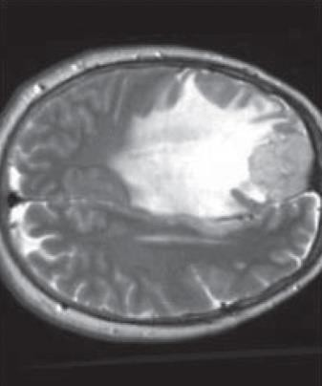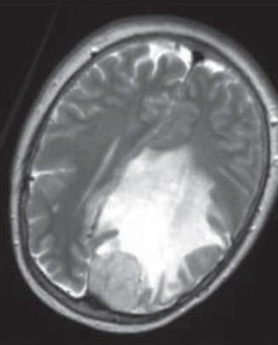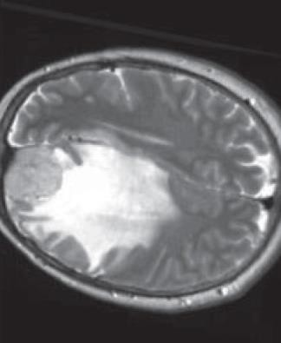

**Figure 5: Clockwise rotation data augmentation: (a) original, (b) 90-degree anticlockwise, (c) 180-degree anticlockwise, and (d) 270-degree anticlockwise.**

Brightness data augmentation technique as shown in Figure [6](https://www.hindawi.com/journals/js/2022/3065656/fig6/) is also applied on in image dataset by taking brightness factor values such as 0.2 and 0.4.

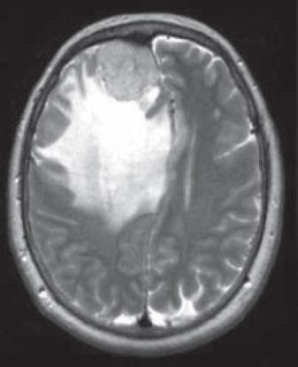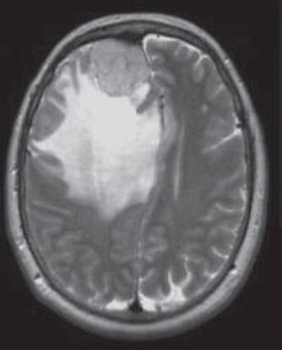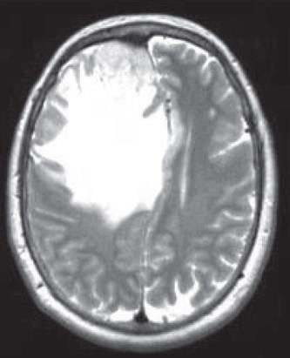

**Figure 6: Brightness data augmentation: (a) original image, (b) with brightness factor 0.2, and (c) with brightness factor 0.4.**

# EXPERIMENTS AND RESULTS:

An experimental evaluation for detection of BT from CT images using four pretrained CNN models such as DenseNet121, DenseNet201, VGG16, and VGG19 is implemented. The CNN models were implemented using CT images collected from the brain tumor Dataset. For training and validating, 432 training images and 104 testing images were used, respectively. The brain MRI images were initially resized from 467x587 to 224x224. An algorithm was implemented using FastAI library. For transfer learning, the models are trained for the batch size 16. Each model was trained for 10 epochs. Both the batch size and number of epochs are determined empirically. Adam optimizer was used to perform training. The learning rate was also empirically decided. The performance of each model was evaluated based on performance metrics such as accuracy, precision, sensitivity, and specificity.

## PERFORMANCE METRICS:

The performance metrics are calculated by various parameters of the confusion matrix such as true positive (TP), false positive (FP), true negative (TN), and false negative (FN) [19]. These confusion matrix parameters are shown below:

*Accuracy*.: Accuracy is defined as the ratio of total number of true predictions to the total number of observed predictions.

*Precision*: Precision is calculated as the number of correct positive predictions divided by the total number of positive predictions.

*Specificity*: Specificity is defined as the number of correct negative predictions divided by the total number of negatives.

*Sensitivity*: Sensitivity is defined as the number of correct positive predictions divided by the total number of positives

## THE TRAINING PERFORMANCE COMPARISON:

Various performance parameters in terms of training loss, validation loss, and error rate, and validation accuracy are obtained by four different models using different epochs and batch size [20]. The model VGG19 was evaluated using 10 epochs with 16 batch size, respectively. For training of all D.L models, Adam optimizer is utilized. From Table [5](https://www.hindawi.com/journals/js/2022/3065656/tab5/), it can be seen that the VGG19 model acquired the highest performance in the testing phase with precision of 100%, sensitivity of 94.73%, specificity of 100%, and yielded accuracy of 98% for batch size 16.

## CONFUSION MATRIX:

The confusion matrices of all D.L models of batch size 16 are shown in Figure [7](https://www.hindawi.com/journals/js/2022/3065656/fig7/). These matrices represent both correct and incorrect predictions. Each and every column is labelled by its class name such as BT and NT. Diagonal values yield accurate number of images classified by the particular model.

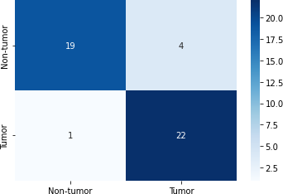

**Figure 7**[**:**](https://www.hindawi.com/journals/js/2022/3065656/fig7/) **Confusion matrix of VGG-19 model with 16 batch size**

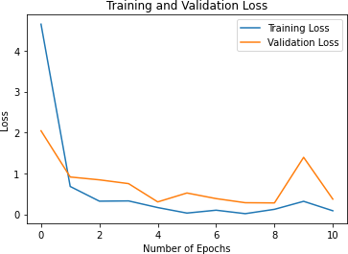

**Figure 8**[**:**](https://www.hindawi.com/journals/js/2022/3065656/fig7/) **Training and Validation Loss**

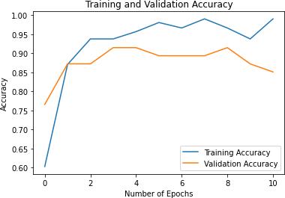

**Figure 9**[**:**](https://www.hindawi.com/journals/js/2022/3065656/fig7/) **Training and Validation Accuracy**

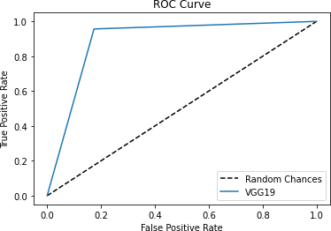

**Figure 10:ROC CURVE**

# CONCLUSION:

VGG19 yield best result as compared with different models using batch size 16. The dataset for BT was acquired from Kaggle. The results are obtained after training and analysis of these models. Further, by properly working on batch sizes, optimizers, and epochs, these results demonstrated the effectiveness of the VGG19 model. Accuracy and sensitivity of 89% and 94.73%, respectively, were achieved with the VGG19 for batch size 16 with Adam optimizer. These comparative results would be cost effective and would help radiologist take a second opinion tool or simulator. The major purpose of this research is to predict BT as early as possible. This comparative analysis model could become a second opinion tool for radiologists. This study helps for more accurate diagnosis for development of D.L models.

Drawback of this proposed study is that only axial dataset of BT samples is used for training and validation purpose. In future, the proposed model can further be generalized by taking coronal and sagittal datasets during training and validation. Also, different pretrained models and optimization techniques could also be implemented to further enhance the effectiveness of the proposed model.

# REFERENCES:

1. X. Gu, Z. Shen, J. Xue, Y. Fan, and T. Ni, “Brain tumor MR image classification using convolutional dictionary learning with local constraint,” *Frontiers in Neuroscience*, vol. 15, 2021.

View at: [Publisher Site](https://doi.org/10.3389/fnins.2021.679847) | [Google Scholar](https://scholar.google.com/scholar_lookup?title=Brain%20tumor%20MR%20image%20classification%20using%20convolutional%20dictionary%20learning%20with%20local%20constraint&author=X.%20Gu%2C%20Z.%20Shen%2C%20J.%20Xue%2C%20Y.%20Fan%2C%20and%20T.%20Ni&publication_year=2021)

1. S. Deepak and P. M. Ameer, “Automated categorization of brain tumor from MRI using CNN features and SVM,” *Journal of Ambient Intelligence and Humanized Computing*, vol. 12, no. 8, pp. 8357–8369, 2021.

View at: [Publisher Site](https://doi.org/10.1007/s12652-020-02568-w) | [Google Scholar](https://scholar.google.com/scholar_lookup?title=Automated%20categorization%20of%20brain%20tumor%20from%20MRI%20using%20CNN%20features%20and%20SVM&author=S.%20Deepak%20and%20P.%20M.%20Ameer&publication_year=2021)

1. R. L. Kumar, J. Kakarla, B. V. Isunuri, and M. Singh, “Multi-class brain tumor classification using residual network and global average pooling,” *Multimedia Tools and Applications*, vol. 80, no. 9, pp. 13429–13438, 2021.

View at: [Publisher Site](https://doi.org/10.1007/s11042-020-10335-4) | [Google Scholar](https://scholar.google.com/scholar_lookup?title=Multi-class%20brain%20tumor%20classification%20using%20residual%20network%20and%20global%20average%20pooling&author=R.%20L.%20Kumar%2C%20J.%20Kakarla%2C%20B.%20V.%20Isunuri%2C%20and%20M.%20Singh&publication_year=2021)

1. A. Rehman, M. A. Khan, T. Saba, Z. Mehmood, U. Tariq, and N. Ayesha, “Microscopic brain tumor detection and classification using 3D CNN and feature selection architecture,” *Microscopy Research and Technique (MRT)*, vol. 84, no. 1, pp. 133–149, 2021. View at: [Publisher Site](https://doi.org/10.1002/jemt.23597) | [Google Scholar](https://scholar.google.com/scholar_lookup?title=Microscopic%20brain%20tumor%20detection%20and%20classification%20using%203D%20CNN%20and%20feature%20selection%20architecture&author=A.%20Rehman%2C%20M.%20A.%20Khan%2C%20T.%20Saba%2C%20Z.%20Mehmood%2C%20U.%20Tariq%2C%20and%20N.%20Ayesha&publication_year=2021)
2. R. Rajasree, C. C. Columbus, and C. Shilaja, “Multiscale-based multimodal image classification of brain tumor using deep learning method,” *Neural Computing and Applications (NCA)*, vol. 33, no. 11, pp. 5543–5553, 2021.

View at: [Publisher Site](https://doi.org/10.1007/s00521-020-05332-5) | [Google Scholar](https://scholar.google.com/scholar_lookup?title=Multiscale-based%20multimodal%20image%20classification%20of%20brain%20tumor%20using%20deep%20learning%20method&author=R.%20Rajasree%2C%20C.%20C.%20Columbus%2C%20and%20C.%20Shilaja&publication_year=2021)

1. I. Abd El Kader, G. Xu, Z. Shuai, S. Saminu, I. Javaid, and I. Salim Ahmad, “Differential deep convolutional neural network model for brain tumor classification,” *Brain Sciences*, vol. 11, no. 3, p. 352, 2021.

View at: [Publisher Site](https://doi.org/10.3390/brainsci11030352) | [Google Scholar](https://scholar.google.com/scholar_lookup?title=Differential%20deep%20convolutional%20neural%20network%20model%20for%20brain%20tumor%20classification&author=I.%20Abd%20El%20Kader%2C%20G.%20Xu%2C%20Z.%20Shuai%2C%20S.%20Saminu%2C%20I.%20Javaid%2C%20and%20I.%20Salim%20Ahmad&publication_year=2021)

1. J. D. Bodapati, N. S. Shaik, V. Naralasetti, and N. B. Mundukur, “Joint training of two- channel deep neural network for brain tumor classification,” *Signal, Image and Video Processing*, vol. 15, no. 4, pp. 753–760, 2021.

View at: [Publisher Site](https://doi.org/10.1007/s11760-020-01793-2) | [Google Scholar](https://scholar.google.com/scholar_lookup?title=Joint%20training%20of%20two-channel%20deep%20neural%20network%20for%20brain%20tumor%20classification&author=J.%20D.%20Bodapati%2C%20N.%20S.%20Shaik%2C%20V.%20Naralasetti%2C%20and%20N.%20B.%20Mundukur&publication_year=2021)

1. H. Mzoughi, I. Njeh, A. Wali et al., “Deep multi-scale 3D convolutional neural network (CNN) for MRI gliomas brain tumor classification,” *Journal of Digital Imaging*, vol. 33, no. 4, pp. 903–915, 2020.

View at: [Publisher Site](https://doi.org/10.1007/s10278-020-00347-9) | [Google Scholar](https://scholar.google.com/scholar_lookup?title=Deep%20multi-scale%203D%20convolutional%20neural%20network%20(CNN)%20for%20MRI%20gliomas%20brain%20tumor%20classification&author=H.%20Mzoughi%2C%20I.%20Njeh%2C%20A.%20Wali%20et%20al.&publication_year=2020)

1. M. Sajjad, S. Khan, K. Muhammad, W. Wu, A. Ullah, and S. W. Baik, “Multi-grade brain tumor classification using deep CNN with extensive data augmentation,” *Journal of Computational Science*, vol. 30, pp. 174–182, 2019.

View at: [Publisher Site](https://doi.org/10.1016/j.jocs.2018.12.003) | [Google Scholar](https://scholar.google.com/scholar_lookup?title=Multi-grade%20brain%20tumor%20classification%20using%20deep%20CNN%20with%20extensive%20data%20augmentation&author=M.%20Sajjad%2C%20S.%20Khan%2C%20K.%20Muhammad%2C%20W.%20Wu%2C%20A.%20Ullah%2C%20and%20S.%20W.%20Baik&publication_year=2019)

1. N. Abiwinanda, M. Hanif, S. T. Hesaputra, A. Handayani, and T. R. Mengko, “Brain tumor classification using convolutional neural network,” *In World Congress on Medical Physics and Biomedical Engineering 218*, Springer, Singapore, pp. 183–189, 2019.

View at: [Google Scholar](https://scholar.google.com/scholar_lookup?title=Brain%20tumor%20classification%20using%20convolutional%20neural%20network&author=N.%20Abiwinanda%2C%20M.%20Hanif%2C%20S.%20T.%20Hesaputra%2C%20A.%20Handayani%2C%20and%20T.%20R.%20Mengko&publication_year=2019)

1. M. A. Khan, I. Ashraf, M. Alhaisoni et al., “Multimodal brain tumor classification using deep learning and robust feature selection: a machine learning application for radiologists,” *Diagnostics*, vol. 10, no. 8, p. 565, 2020.

View at: [Google Scholar](https://scholar.google.com/scholar_lookup?title=Multimodal%20brain%20tumor%20classification%20using%20deep%20learning%20and%20robust%20feature%20selection%3A%20a%20machine%20learning%20application%20for%20radiologists&author=M.%20A.%20Khan%2C%20I.%20Ashraf%2C%20M.%20Alhaisoni%20et%20al.&publication_year=2020)

1. Y. Xu, Z. Jia, Y. Ai et al., “Deep convolutional activation features for large scale brain tumor histopathology image classification and segmentation,” in *In 2015 IEEE international conference on acoustics, speech and signal processing*, pp. 947–951, South Brisbane, QLD, Australia, April 2015.

View at: [Publisher Site](https://doi.org/10.1109/ICASSP.2015.7178109) | [Google Scholar](https://scholar.google.com/scholar_lookup?title=Deep%20convolutional%20activation%20features%20for%20large%20scale%20brain%20tumor%20histopathology%20image%20classification%20and%20segmentation&author=Y.%20Xu%2C%20Z.%20Jia%2C%20Y.%20Ai%20et%20al)

1. T. Sadad, A. Rehman, A. Munir et al., “Brain tumor detection and multi-classification using advanced deep learning techniques,” *Microscopy Research and Technique*, vol. 84, no. 6, pp. 1296–1308, 2021.

View at: [Publisher Site](https://doi.org/10.1002/jemt.23688) | [Google Scholar](https://scholar.google.com/scholar_lookup?title=Brain%20tumor%20detection%20and%20multi-classification%20using%20advanced%20deep%20learning%20techniques&author=T.%20Sadad%2C%20A.%20Rehman%2C%20A.%20Munir%20et%20al.&publication_year=2021)

1. C. Shao, Y. Yang, S. Juneja, and T. GSeetharam, “IoT data visualization for business intelligence in corporate finance,” *Information Processing and Management*, vol. 59, no. 1, p. 102736, 2022.

View at: [Publisher Site](https://doi.org/10.1016/j.ipm.2021.102736) | [Google Scholar](https://scholar.google.com/scholar_lookup?title=IoT%20data%20visualization%20for%20business%20intelligence%20in%20corporate%20finance&author=C.%20Shao%2C%20Y.%20Yang%2C%20S.%20Juneja%2C%20and%20T.%20GSeetharam&publication_year=2022)

1. S. Juneja, M. Gahlan, G. Dhiman, and S. Kautish, “Futuristic cyber-twin architecture for 6G technology to support internet of everything,” *Scientific Programming. Hindawi Limited*, vol. 2021, pp. 1–7, 2021.

View at: [Publisher Site](https://doi.org/10.1155/2021/9101782) | [Google Scholar](https://scholar.google.com/scholar_lookup?title=Futuristic%20cyber-twin%20architecture%20for%206G%20technology%20to%20support%20internet%20of%20everything&author=S.%20Juneja%2C%20M.%20Gahlan%2C%20G.%20Dhiman%2C%20and%20S.%20Kautish&publication_year=2021)

1. S. Juneja, S. Jain, A. Suneja et al., “Gender and age classification enabled blockschain security mechanism for assisting mobile application,” *IETE Journal of Research*, pp. 1–13, 2021.

View at: [Publisher Site](https://doi.org/10.1080/03772063.2021.1982418) | [Google Scholar](https://scholar.google.com/scholar_lookup?title=Gender%20and%20age%20classification%20enabled%20blockschain%20security%20mechanism%20for%20assisting%20mobile%20application&author=S.%20Juneja%2C%20S.%20Jain%2C%20A.%20Suneja%20et%20al.&publication_year=2021)

1. S. Juneja, G. Dhiman, S. Kautish, W. Viriyasitavat, and K. Yadav, “A perspective roadmap for IoMT-based early detection and care of the neural disorder, dementia,” *Journal of Healthcare Engineering*, vol. 2021, 11 pages, 2021.

View at: [Publisher Site](https://doi.org/10.1155/2021/6712424) | [Google Scholar](https://scholar.google.com/scholar_lookup?title=A%20perspective%20roadmap%20for%20IoMT-based%20early%20detection%20and%20care%20of%20the%20neural%20disorder%2C%20dementia&author=S.%20Juneja%2C%20G.%20Dhiman%2C%20S.%20Kautish%2C%20W.%20Viriyasitavat%2C%20and%20K.%20Yadav&publication_year=2021)

1. S. Juneja, A. Juneja, G. Dhiman, S. Behl, and S. Kautish, “An approach for thoracic syndrome classification with convolutional neural networks,” *Computational and Mathematical Methods in Medicine*, vol. 2021, 10 pages, 2021.

View at: [Publisher Site](https://doi.org/10.1155/2021/3900254) | [Google Scholar](https://scholar.google.com/scholar_lookup?title=An%20approach%20for%20thoracic%20syndrome%20classification%20with%20convolutional%20neural%20networks&author=S.%20Juneja%2C%20A.%20Juneja%2C%20G.%20Dhiman%2C%20S.%20Behl%2C%20and%20S.%20Kautish&publication_year=2021)

1. H. K. Upadhyay, S. Juneja, S. Maggu, G. Dhingra, and A. Juneja, “Multi-criteria analysis of social isolation barriers amid COVID-19 using fuzzy AHP,” *World Journal of Engineering*, vol. 19, no. 2, pp. 195–203, 2022.

View at: [Publisher Site](https://doi.org/10.1108/WJE-04-2021-0195) | [Google Scholar](https://scholar.google.com/scholar_lookup?title=Multi-criteria%20analysis%20of%20social%20isolation%20barriers%20amid%20COVID-19%20using%20fuzzy%20AHP&author=H.%20K.%20Upadhyay%2C%20S.%20Juneja%2C%20S.%20Maggu%2C%20G.%20Dhingra%2C%20and%20A.%20Juneja&publication_year=2022)

1. A. Juneja, S. Juneja, A. Soneja, and S. Jain, “Real time object detection using CNN based single shot detector model,” *Journal of Information Technology Management*, vol. 13, no. 1, pp. 62–80, 2021.

View at: [Publisher Site](https://doi.org/10.22059/jitm.2021.80025) | [Google Scholar](https://scholar.google.com/scholar_lookup?title=Real%20time%20object%20detection%20using%20CNN%20based%20single%20shot%20detector%20model&author=A.%20Juneja%2C%20S.%20Juneja%2C%20A.%20Soneja%2C%20and%20S.%20Jain&publication_year=2021)